**KONGU ENGINEERING COLLEGE**

**(Autonomous)**

**PERUNDURAI ERODE-638060**

**DEPARTMENT OF COMPUTER SCIENCE AND**

**ENGINEERING**



# WEB TECHNOLOGY PROJECT

BY,

SNEKA A

21CSR196

CSE-D

DESIGN A ONLINE WEBSITE FOR PETSHOP

AIM:

To design a online petshop application using HTML and CSS.

**-------HOME PAGE------HTML-------**

<!DOCTYPE html>

<html lang="en">

<head>

<meta charset="utf-8">

<meta name="viewport" content="width=device-width, initial-scale=1">

<link rel="stylesheet" href="style1.css">

<link href="https://cdn.jsdelivr.net/npm/bootstrap@5.0.2/dist/css/bootstrap.min.css" rel="stylesheet">

</head>

<body>

<!----Navbar-->

<nav class="navbar navbar-expand-lg navbar-dark" id="navbar">

<div class="container-fluid">

<a class="navbar-brand" href="#">SHIYA PETSHOP</a>

<button class="navbar-toggler" type="button" data-bs-toggle="collapse" data-bs-target="#navbarSupportedContent" aria-controls="navbarSupportedContent" aria-expanded="false" aria-label="Toggle navigation">

<span class="navbar-toggler-icon"></span>

</button>

<div class="collapse navbar-collapse" id="navbarSupportedContent">

<ul class="navbar-nav mx-auto ">

<li class="nav-item">

</li>

<li class="nav-item">

<a class="nav-link" href="login.html">Login</a>

</li>

<li class="nav-item">

<a class="nav-link" href="reg.html"> Register</a>

<ul class="dropdown-menu" aria-labelledby="navbarDropdown">

<li class="nav-item">

<a class="nav-link" href="pf.html">Payment</a>

</li>

<li><a class="dropdown-item" href="#">Action</a></li>

</ul>

</li>

<li class="nav-item">

<a class="nav-link" href="pf.html">Payment</a>

</li>

</ul>

<form class="d-flex">

<input class="form-control me-2" type="search" placeholder="Search" aria-label="Search">

<button class="btn p-2 my-lg-0 my-2" type="submit">Search</button>

</form>

</div>

</div>

</nav>

</div>

<div class="collapse navbar-collapse" id="myNavbar">

<ul class="nav navbar-nav">

<li><a href="About.html">About Us</a></li>

<li class="dropdown">

<a class="dropdown-toggle" data-toggle="dropdown"href="login.html">Login<span class="caret"</span></a>

<ul class="dropdown-menu">

</ul>

</li>

<li><a href="com.html" target=" blank">Register</a></li>

<li><a href="pf.html" target=" blank">Payment</a></li>

<li><a href="login.html"></a></li>

<li><a href="app.html"></a></li>

</ul>

</div>

</div>

</nav>

<img src="https://media.istockphoto.com/id/1414375324/photo/chihuahua-and-west-highland-terrier-dogs-sitting-in-petshop.jpg?b=1&s=170667a&w=0&k=20&c=UdT86BG02ZeyFsoXZUdIVm6FJT14JI83Zq8JwsPfZx0=" class="img-fluid" alt="Responsive image" width="1350" height="600">

<br></br>

</div>

</head>

<!----About---->

<section id="about">

<div class="container-fluid">

<div class="row">

<div class="col-lg-6 col-md-6 col-12">

<img src="https://encrypted-tbn0.gstatic.com/images?q=tbn:ANd9GcQDl1rywtQsDcakA9lfPHLaKEV4UGjJbJWuNQ&usqp=CAU" height="400" width="500" class="img-fluid" alt="Responsive image">

</div>

<div class="col-lg-6 col-md-6 col-12">

<h1>ABOUT US</h1>

<p id="myP" onmousedown="mouseDown()" onmouseup="mouseUp()">SHIYA Pets SHOP is one of the leading pet shops in Coimbatore. The shop is located in Coimbatore, India. They have dogs, birds, cats and aquarium fishes (Marine and Freshwater) of quality breeds in excellent health condition and temperament. All their pets are handpicked with excellent quality and good lineage. They sell dogs like pugs, Dobermans, rottweilers, great dane, boxers, golden retrievers, rajapalyam, chipiparai, kombai, dachshunds, beagles, labrador retrievers, german shepherds, chihuahua and other exotic dogs as mentioned in their Dogs section based on the order. They sell birds like cockatoos, macaws, African greys, conures, amazons, African birds and other exotic birds on an order basis.</p>

</section>

<script>

function mouseDown() {

document.getElementById("myP").style.color = "blue";

}

function mouseUp() {

document.getElementById("myP").style.color = "red";

}

</script>

</div>

</div>

</section>

<section id="pets">

<div class="container m-5">

<h1 class="text-center my-5">OUR PETS</h1>

<div class="row">

<div class="col-lg-4 col-md-4 col-12">

<div class="card">

<img src="https://images.pexels.com/photos/1741205/pexels-photo-1741205.jpeg?cs=srgb&dl=pexels-lina-kivaka-1741205.jpg&fm=jpg&_gl=1*1566s29*_ga*MzQ5MzY2ODQwLjE2ODI2MjU0NDE.*_ga_8JE65Q40S6*MTY4MjYyNTQ1Mi4xLjEuMTY4MjYyNTQ5Mi4wLjAuMA.." class="card-img-top">

<div class="card-body text-center">

<h5 class="card-title">CAT</h5>

<a href="reg.html" class="btn btn-primary">Buy Now</a>

</div>

</div>

</div>

<div class="col-lg-4 col-md-4 col-12">

<div class="card">

<img src="https://images.pexels.com/photos/1805164/pexels-photo-1805164.jpeg?auto=compress&cs=tinysrgb&w=600" class="card-img-top">

<div class="card-body">

<h5 class="card-title text-center">DOGGY</h5>

<a href="reg.html" class="btn btn-primary">Buy Now</a>

</div>

</div>

</div>

<br></br>

<div class="col-lg-4 col-md-4 col-12">

<div class="card">

<img src="https://images.pexels.com/photos/6897444/pexels-photo-6897444.jpeg?auto=compress&cs=tinysrgb&w=600" class="card-img-top">

<div class="card-body">

<h5 class="card-title text-center">Rabbit</h5>

<a href="reg.html" class="btn btn-primary">Buy Now</a>

</div>

</div>

</div>

<br></br>

<hr></hr>

<div class="col-lg-4 col-md-4 col-12">

<div class="card">

<img src="https://cf.ltkcdn.net/aquariums/fish-names/images/std/324592-800x533-goldfish-swimming-in-fish-tank.webp" class="card-img-top">

<div class="card-body">

<h5 class="card-title text-center">Golden fish</h5>

<a href="reg.html" class="btn btn-primary">Buy Now</a>

</div>

</div>

</div>

<br></br>

<div class="col-lg-4 col-md-4 col-12">

<div class="card">

<img src="https://img.freepik.com/premium-photo/budgerigar-tree-branch-with-sunset-sunlight-ai-genarated_858234-3.jpg?w=2000" class="card-img-top">

<div class="card-body">

<h5 class="card-title text-center">Budgeriga</h5>

<a href="reg.html" class="btn btn-primary">Buy Now</a>

</div>

</div>

</div>

<br></br>

<div class="col-lg-4 col-md-4 col-12">

<div class="card">

<img src="https://www.bostonveterinary.com/wp-content/uploads/2022/03/ferret-care-boston-ma.jpg" class="card-img-top">

<div class="card-body">

<h5 class="card-title text-center">Ferret </h5>

<a href="reg.html" class="btn btn-primary">Buy Now</a>

</div>

</div>

</div>

<br></br>

<hr></hr>

<div class="col-lg-4 col-md-4 col-12">

<div class="card">

<img src="https://www.hepper.com/wp-content/uploads/2023/04/close-up-of-a-lutino-cockatiel-bird_Miss-Nachcha-Chayapan_Shutterstock.jpg" class="card-img-top">

<div class="card-body">

<h5 class="card-title text-center">Cockatiel </h5>

<a href="reg.html" class="btn btn-primary">Buy Now</a>

</div>

</div>

</div>

<br></br>

<br></br>

<div class="col-lg-4 col-md-4 col-12">

<div class="card">

<img src="https://supremepetfoods.com/wp-content/uploads/2020/06/shutterstock_413075458-510x305.jpg" class="card-img-top">

<div class="card-body">

<h5 class="card-title text-center">guinea pig </h5>

<a href="reg.html" class="btn btn-primary">Buy Now</a>

</div>

</div>

</div>

<br></br>

<div class="col-lg-4 col-md-4 col-12">

<div class="card">

<img src="https://www.aafco.org/wp-content/uploads/2023/01/iStock-1361708626.jpg" class="card-img-top">

<div class="card-body">

<h5 class="card-title text-center">Pet Foods</h5>

<a href="reg.html" class="btn btn-primary">Buy Now</a>

</div>

</div>

</div>

<br></br>

<hr></hr>

<div class="col-lg-4 col-md-4 col-12">

<div class="card">

<img src="https://www.petzo.net/wp-content/uploads/2022/01/Yellow-Duck-Cozy-Pet-House-Kennel-Bed1.jpg" class="card-img-top">

<div class="card-body">

<h5 class="card-title text-center">House kennalbed</h5>

<a href="reg.html" class="btn btn-primary">Buy Now</a>

</div>

</div>

</div>

<br></br>

<div class="col-lg-4 col-md-4 col-12">

<div class="card">

<img src="https://i.etsystatic.com/22414130/r/il/64bd97/3192765790/il_fullxfull.3192765790_7o42.jpg" class="card-img-top">

<div class="card-body">

<h5 class="card-title text-center">Collers</h5>

<a href="reg.html" class="btn btn-primary">Buy Now</a>

</div>

</div>

</div>

<br></br>

<div class="col-lg-4 col-md-4 col-12">

<div class="card">

<img src="https://ak1.ostkcdn.com/images/products/8815264/Friends-Forever-Cuffed-Rectangular-Cuddler-L16049663.jpg" class="card-img-top">

<div class="card-body">

<h5 class="card-title text-center">Beds</h5>

<a href="reg.html" class="btn btn-primary">Buy Now</a>

</div>

</div>

</div>

<br></br>

</div>

</div>

</section>

<!-- contact section start -->

<link href="https://cdn.jsdelivr.net/npm/bootstrap@5.0.2/dist/css/bootstrap.min.css" rel="stylesheet">

<div class="contact-section" id="contact">

<div class="image-area"></div>

<div class="form-area">

<div class="form-wrap">

<div class="title">

<h1>Contact Us</h1>

</div>

<div class="contact-area">

<div class="contact-info">

<h2>Information</h2>

<div class="contact-address">

<span class="icon-map-marked-alt"></span>

<p>D.no 27 100feet road, near Mariamman Koil Street, Gandhipuram, Tamil Nadu 641012</p>

</div>

<div class="contact-mail">

<span class="icon-envelope"></span>

<p>shiyapetsak@gmail.com</p>

</div>

<div class="contact-phone">

<span class="icon-phone-alt"></span>

<p>+88 0123-456-789</p>

</div>

</div>

<form class="contact-form">

<div class="name-field">

<div class="input-area">

<input type="text" id="fname" autocomplete="off" required>

<label for="fname">First Name</label>

</div>

<div class="input-area">

<input type="text" id="lname" autocomplete="off" required>

<label for="lname">Last Name</label>

</div>

</div>

<div class="input-area">

<input type="email" id="email" autocomplete="off" required>

<label for="email">Email</label>

</div>

<div class="message-area">

<textarea id="message" required></textarea>

<label for="message">Message</label>

</div>

<div class="btn">

<input type="submit" name="submit" value="Submit" formaction="http://localhost:5000/save">

</div>

</form>

</div>

</div>

</div>

</div>

<!-- contact section end -->

<script src="https://cdn.jsdelivr.net/npm/@popperjs/core@2.9.2/dist/umd/popper.min.js"></script>

<script src="https://cdn.jsdelivr.net/npm/bootstrap@5.0.2/dist/js/bootstrap.min.js"></script>

</body>

</html>

**-------HOMEPAGE----- CSS-------**

@import url('https://fonts.googleapis.com/css2?family=Lobster&family=Poppins:wght@600&display=swap');

*{

margin: 0;

padding: 0%;

box-sizing: border-box;

font-family: 'Poppins', sans-serif;

}

#navbar{

position: sticky;

top: 0;

left: 0;

z-index: 100;

padding: .5rem 5rem;

box-shadow: 5px 5px 20px rgba(0,0,0.5);

background: black;

}

.navbar .navbar-brand{

font-size: 25px;

font-weight: 800;

color: #f9629f !important;

}

#navbarSupportedContent a{

color: #ffff;

border-bottom: 2px solid transparent;

}

#navbarSupportedContent a:hover{

border-bottom: 2px solid #f9629f;

}

#pets img{

width: 250px;

height: 250px;

}

.card{

width: 250px;

height: 300px;

background: #e5e5e5 !important;

box-shadow: 5px 20px 20px rgba(0,0,0,.3),

inset 4px 4px 10px white;

border-radius: 20px !important;

overflow: hidden;

justify-content: center;

align-items: center;

}

/* =========================

Contact Section Start

=========================== */

.contact-section {

height: 800px;

width: 100%;

}

.contact-section .image-area {

height: 50%;

width: 100%;

background: -o-linear-gradient(45deg, rgba(0, 0, 0, 0.5), rgba(0, 0, 0, 0.7)), url('https://images.pexels.com/photos/8939507/pexels-photo-8939507.jpeg?auto=compress&cs=tinysrgb&w=1260&h=750&dpr=1');

background: linear-gradient(45deg, rgba(0, 0, 0, 0.5), rgba(0, 0, 0, 0.7)), url('https://images.pexels.com/photos/8939507/pexels-photo-8939507.jpeg?auto=compress&cs=tinysrgb&w=1260&h=750&dpr=1');

background-size: cover;

background-position: center;

background-attachment: fixed;

}

.contact-section .form-area {

position: relative;

height: 50%;

width: 100%;

background: #fff;

-webkit-box-sizing: border-box;

box-sizing: border-box;

}

.form-area .form-wrap {

position: absolute;

top: -78%;

left: 50%;

-webkit-transform: translateX(-50%);

-ms-transform: translateX(-50%);

transform: translateX(-50%);

height: 620px;

width: 1120px;

background: url('img/background/contact.jpg');

background-size: cover;

background-position: center;

border-radius: 0.2rem;

-webkit-box-sizing: border-box;

box-sizing: border-box;

-webkit-box-shadow: 0 0 0.4rem 0 #0e0101;

box-shadow: 0 0 0.4rem 0 #0c0202;

}

.form-wrap .title {

padding-top: 2.4rem;

width: 100%;

-webkit-box-sizing: border-box;

box-sizing: border-box;

}

.form-wrap .title h1 {

color: #61790a;

font-size: 2.6rem;

text-align: center;

}

.form-wrap .contact-area {

padding-top: 3rem;

display: -webkit-box;

display: -ms-flexbox;

display: flex;

width: 100%;

height: auto;

-webkit-box-sizing: border-box;

box-sizing: border-box;

}

.contact-area .contact-info {

width: 35%;

height: 100%;

margin-left: 6rem;

}

.contact-info>h2 {

padding-top: 0.2rem;

margin-bottom: 1.4rem;

color: #61790a;

font-size: 2rem;

}

.contact-info>div {

margin-bottom: 1rem;

display: -webkit-box;

display: -ms-flexbox;

display: flex;

-webkit-box-align: center;

-ms-flex-align: center;

align-items: center;

}

.contact-info>div>p {

color: #1e0303;

font-size: 1.4rem;

font-weight: 500;

}

.contact-info>div>span {

color: #61790a;

font-size: 2rem;

margin-right: 0.8rem;

}

.contact-area .contact-form {

display: -webkit-box;

display: -ms-flexbox;

display: flex;

-webkit-box-orient: vertical;

-webkit-box-direction: normal;

-ms-flex-direction: column;

flex-direction: column;

width: 60%;

height: auto;

padding: 0 3rem;

-webkit-box-sizing: border-box;

box-sizing: border-box;

}

.contact-form .name-field {

display: -webkit-box;

display: -ms-flexbox;

display: flex;

-webkit-box-pack: justify;

-ms-flex-pack: justify;

justify-content: space-between;

}

.name-field .input-area {

width: 48%;

}

.contact-form .input-area {

position: relative;

margin-bottom: 2rem;

}

.input-area input {

height: 3rem;

width: 100%;

color: #333;

font-size: 1.2rem;

border: 2px solid #fff;

border-radius: 0.2rem;

background: #eff;

-webkit-box-shadow: 0 0 0.1rem #666;

box-shadow: 0 0 0.1rem #666;

outline: none;

padding: 0 1rem;

-webkit-box-sizing: border-box;

box-sizing: border-box;

-webkit-transition: all 0.3s ease;

-o-transition: all 0.3s ease;

transition: all 0.3s ease;

}

.input-area label {

position: absolute;

top: 50%;

left: 1rem;

-webkit-transform: translateY(-50%);

-ms-transform: translateY(-50%);

transform: translateY(-50%);

color: #333;

font-size: 1.2rem;

font-weight: 500;

-webkit-transition: all 0.3s ease;

-o-transition: all 0.3s ease;

transition: all 0.3s ease;

}

.input-area input:focus~label,

.input-area input:valid~label {

top: -0.8rem;

left: 0;

color: #fff;

background: #111;

padding: 0.2rem;

font-size: 1rem;

}

.contact-form .message-area {

position: relative;

-webkit-box-flex: 1;

-ms-flex: 1 1 auto;

flex: 1 1 auto;

height: 200px;

width: 100%;

}

.message-area textarea {

height: 100%;

width: 100%;

border: 2px solid #fff;

outline: none;

font-size: 1.2rem;

padding: 1rem;

color: #333;

background: #eff;

-webkit-box-sizing: border-box;

box-sizing: border-box;

-webkit-box-shadow: 0 0 0.1rem #666;

box-shadow: 0 0 0.1rem #666;

border-radius: 0.2rem;

resize: vertical;

-webkit-transition: all 0.3s ease;

-o-transition: all 0.3s ease;

transition: all 0.3s ease;

}

.message-area label {

position: absolute;

color: #333;

font-weight: 500;

font-size: 1.2rem;

top: 1rem;

left: 1rem;

-webkit-transition: all 0.3s ease;

-o-transition: all 0.3s ease;

transition: all 0.3s ease;

}

.message-area textarea:focus~label,

.message-area textarea:valid~label {

top: -1.6rem;

left: 0;

color: #fff;

padding: 0.2rem;

background: #111;

font-size: 1rem;

}

.contact-form .btn {

margin-top: 1.8rem;

}

.contact-form .btn button {

height: 3.2rem;

width: 8rem;

border: none;

outline: none;

color: #fff;

font-size: 1.2rem;

background: #61790a;

border-radius: 0.1rem;

cursor: pointer;

}

#contact.menu-active {

padding-top: 2rem;

}

/* =======================

Contact Section End

========================= */

**------LOGIN PAGE--------HTML-----------**

<!DOCTYPE html>

<html lang="en">

<head>

<meta charset="UTF-8">

<meta http-equiv="X-UA-Compatible" content="IE=edge">

<meta name="viewport" content="width=device-width, initial-scale=1.0">

<title>login</title>

<link rel="stylesheet" href="style.css">

</head>

<body>

<form method="post">

<h1>LOGIN</h1>

<label>UserName</label>

<input type="text" name="name">

<label>Password</label>

<input type="password" password="password">

<button type="submit" onclick="alert('Login Successfully completed!')"formaction="http://localhost:5000/save">Login</button>

<a>Forget Password?</a>

</form>

</body>

</html>

**------LOGIN CSS--------**

@import url('https://fonts.googleapis.com/css2?family=Poppins:ital,wght@1,600&display=swap');

* {

margin: 100;

padding: 0;

box-sizing: border-box;

font-family: 'Lobster', cursive;

cursor: pointer;

}

body{

height: 100vh;

width: 100%;

display: flex;

justify-content: center;

align-items: center;

background: linear-gradient(to right,hsl(240, 10%, 6%),#0a0304);

background-image: url("https://static.wixstatic.com/media/41d000_ebcc952c6f5616e787d4140940159ec8.jpg/v1/fill/w_638,h_330,al_c,q_80,usm_0.66_1.00_0.01,enc_auto/41d000_ebcc952c6f5616e787d4140940159ec8.jpg" );

/* Full height */

height: 100;

/* Center and scale the image nicely */

background-position: center;

background-repeat: no-repeat;

background-size: cover;

}

form{

font-size: 20px;

width: 25rem;

height: 28rem;

display: flex;

flex-direction: column;

background: hsla(125, 20%, 67%, 0.353);

box-shadow: 0 8px 32px 0 #000109;

border-radius: 30px;

border-left: 1px solid rgba(11, 2, 2, 0.3);

border-top: 1px solid rgb(17, 16, 16);

}

h1{

font-size: 50px;

text-align: center;

color: rgb(13, 1, 1);

text-shadow: 2px 2px 4px rgba(0,0,0,.2);

letter-spacing: 3px;

margin-bottom: 5%;

opacity: .7S;

}

label{

color: rgb(15, 6, 6);

color: rgb(0, 0, 0);

margin-left: 10%;

opacity: .8;

text-shadow: 2px 2px 4px rgba(0,0,0,.2);

}

input{

width: 80%;

margin: 5% auto;

margin-bottom: 8%;

border :none;

order :none;

background: transparent ;

color: #141010;

border-bottom: 1px solid rgba(17, 1, 1, 0.6);

opacity: .8;

}

button{

width: 50%;

margin: 3% auto;

color: rgb(15, 1, 1);

font-size: 25px;

opacity: .7;

background: rgba(22, 1, 1, 0.06);

padding: 10px 30px;

border :none;

order :none;

border-radius: 20px;

text-shadow: 2px 2px 4px #010000ef;

box-shadow: 3px 3px 5px #000004d3;

border-left: 1px solid rgba(0, 0, 0, 0.9);

border-top: 1px solid #000000e9;

}

a{

font-size: 20px;

text-align: center;

color: rgb(10, 3, 3);

opacity: .7;

}

**-----REGISTER FORM WITH VALIDATION HTML--------**

<!DOCTYPE html>

<html lang="en">

<head>

<meta charset="UTF-8">

<meta name="viewport" content="width=device-width, initial-scale=1.0">

<title>Payment Form</title>

<link href="paymentform.css" rel="stylesheet">

<link href="https://stackpath.bootstrapcdn.com/font-awesome/4.7.0/css/font-awesome.min.css" rel="stylesheet"

integrity="sha384-wvfXpqpZZVQGK6TAh5PVlGOfQNHSoD2xbE+QkPxCAFlNEevoEH3Sl0sibVcOQVnN" crossorigin="anonymous">

<link rel="stylesheet" href="paymentform.css">

</head>

<body>

<div class="wrapper">

<h2>Payment Form</h2>

<form method="POST">

<h4>Account</h4>

<div class="input-group">

<div class="input-box">

<input type="text" placeholder="Full Name" required class="name">

<i class="fa fa-user icon"></i>

</div>

<div class="input-box">

<input type="text" placeholder="Nick Name" required class="name">

<i class="fa fa-user icon"></i>

</div>

</div>

<div class="input-group">

<div class="input-box">

<input type="email" placeholder="Email Adress" required class="name">

<i class="fa fa-envelope icon"></i>

</div>

</div>

<div class="input-group">

<div class="input-box">

<h4> Date of Birth</h4>

<input type="text" placeholder="DD" class="dob">

<input type="text" placeholder="MM" class="dob">

<input type="text" placeholder="YYYY" class="dob">

</div>

<div class="input-box">

<h4> Gender</h4>

<input type="radio" id="b1" name="gendar" checked class="radio">

<label for="b1">Male</label>

<input type="radio" id="b2" name="gendar" class="radio">

<label for="b2">Female</label>

</div>

</div>

<div class="input-group">

<div class="input-box">

<h4>Payment Details</h4>

<input type="radio" name="pay" id="bc1" checked class="radio">

<label for="bc1"><span><i class="fa fa-cc-visa"></i> Credit Card</span></label>

<input type="radio" name="pay" id="bc2" class="radio">

<label for="bc2"><span><i class="fa fa-cc-paypal"></i> Paypal</span></label>

</div>

</div>

<div class="input-group">

<div class="input-box">

<input type="tel" placeholder="Card Number" required class="name">

<i class="fa fa-credit-card icon"></i>

</div>

</div>

<div class="input-group">

<div class="input-box">

<input type="tel" placeholder="Card CVC" required class="name">

<i class="fa fa-user icon"></i>

</div>

<div class="input-box">

<select>

<option>01 jun</option>

<option>02 jun</option>

<option>03 jun</option>

</select>

<select>

<option>2021</option>

<option>2022</option>

<option>2023</option>

</select>

</div>

</div>

<div class="input-group">

<div class="input-box">

<button type="PAY NOW" name="PAY NOW" value="PAYNOW" formaction="http://localhost:5000/save">PAY NOW

</div>

</div>

</form>

</div>

</body>

</html>

**-------REGISTER FORM WITH CSS--------**

@import url("https://fonts.googleapis.com/css2?family=Oswald&display=swap");

* {

margin: 0

}

.container {

display: flex;

justify-content: center;

align-items: center;

flex-direction: column;

height: 100vh;

background-color: #9b415c;

}

h1 {

color: white;

font-family: "Oswald", sans-serif;

margin: 20px 0;

text-align: center;

}

.registartion-form {

display: flex;

justify-content: center;

align-items: center;

width: 500px;

color: #fff;

font-size: 18px;

font-family: sans-serif;

background-color: hsla(323, 63%, 53%, 0.882);

padding: 20px;

}

.registartion-form input,

.registartion-form select,

.registartion-form textarea {

border: none;

padding: 5px;

margin-top: 10px;

font-family: sans-serif;

}

.registartion-form input:focus,

.registartion-form textarea:focus {

outline: none;

box-shadow: 0 0 10px rgb(228, 228, 228), 0 0 10px rgb(224, 224, 224);

}

.registartion-form .submit {

width: 100%;

padding: 8px 0;

font-size: 20px;

font-weight: 700;

color: #333;

background-color: #fff;

border-radius: 5px;

}

.registartion-form .submit:hover {

box-shadow: 0 0 5px rgba(255, 255, 255, 0.5);

}

**-------REGISTER FORM WITH VALIDATION JS--------**

// Select all input elements for varification

const name = document.getElementById("name");

const email = document.getElementById("email");

const password = document.getElementById("password");

const phoneNumber = document.getElementById("phoneNumber");

const gender = document.registration;

const language = document.getElementById("language");

const zipcode = document.getElementById("zipcode");

// function for form varification

function formValidation() {

// checking name length

if (name.value.length < 2 || name.value.length > 20) {

alert("Name length should be more than 2 and less than 21");

name.focus();

return false;

}

// checking email

if (email.value.match(/^\w+([\.-]?\w+)*@\w+([\.-]?\w+)*(\.\w{2,3})+$/)) {

alert("Please enter a valid email!");

email.focus();

return false;

}

// checking password

if (!password.value.match(/^.{5,15}$/)) {

alert("Password length must be between 5-15 characters!");

password.focus();

return false;

}

// checking phone number

if (!phoneNumber.value.match(/^[1-9][0-9]{9}$/)) {

alert("Phone number must be 10 characters long number and first digit can't be 0!");

phoneNumber.focus();

return false;

}

// checking gender

if (gender.gender.value === "") {

alert("Please select your gender!");

return false;

}

// checking language

if (language.value === "") {

alert("Please select your language!")

return false;

}

// checking zip code

if (!zipcode.value.match(/^[0-9]{6}$/)) {

alert("Zip code must be 6 characters long number!");

zipcode.focus();

return false;

}

return true;}

**-------PAYMENT FORM HTML--------**

<!DOCTYPE html>

<html lang="en">

<head>

<meta charset="UTF-8">

<meta name="viewport" content="width=device-width, initial-scale=1.0">

<title>Payment Form</title>

<link href="paymentform.css" rel="stylesheet">

<link href="https://stackpath.bootstrapcdn.com/font-awesome/4.7.0/css/font-awesome.min.css" rel="stylesheet"

integrity="sha384-wvfXpqpZZVQGK6TAh5PVlGOfQNHSoD2xbE+QkPxCAFlNEevoEH3Sl0sibVcOQVnN" crossorigin="anonymous">

<link rel="stylesheet" href="paymentform.css">

</head>

<body>

<div class="wrapper">

<h2>Payment Form</h2>

<form method="POST">

<h4>Account</h4>

<div class="input-group">

<div class="input-box">

<input type="text" placeholder="Full Name" required class="name">

<i class="fa fa-user icon"></i>

</div>

<div class="input-box">

<input type="text" placeholder="Nick Name" required class="name">

<i class="fa fa-user icon"></i>

</div>

</div>

<div class="input-group">

<div class="input-box">

<input type="email" placeholder="Email Adress" required class="name">

<i class="fa fa-envelope icon"></i>

</div>

</div>

<div class="input-group">

<div class="input-box">

<h4> Date of Birth</h4>

<input type="text" placeholder="DD" class="dob">

<input type="text" placeholder="MM" class="dob">

<input type="text" placeholder="YYYY" class="dob">

</div>

<div class="input-box">

<h4> Gender</h4>

<input type="radio" id="b1" name="gendar" checked class="radio">

<label for="b1">Male</label>

<input type="radio" id="b2" name="gendar" class="radio">

<label for="b2">Female</label>

</div>

</div>

<div class="input-group">

<div class="input-box">

<h4>Payment Details</h4>

<input type="radio" name="pay" id="bc1" checked class="radio">

<label for="bc1"><span><i class="fa fa-cc-visa"></i> Credit Card</span></label>

<input type="radio" name="pay" id="bc2" class="radio">

<label for="bc2"><span><i class="fa fa-cc-paypal"></i> Paypal</span></label>

</div>

</div>

<div class="input-group">

<div class="input-box">

<input type="tel" placeholder="Card Number" required class="name">

<i class="fa fa-credit-card icon"></i>

</div>

</div>

<div class="input-group">

<div class="input-box">

<input type="tel" placeholder="Card CVC" required class="name">

<i class="fa fa-user icon"></i>

</div>

<div class="input-box">

<select>

<option>01 jun</option>

<option>02 jun</option>

<option>03 jun</option>

</select>

<select>

<option>2021</option>

<option>2022</option>

<option>2023</option>

</select>

</div>

</div>

<div class="input-group">

<div class="input-box">

<button type="PAY NOW" name="PAY NOW" value="PAYNOW" formaction="http://localhost:5000/save">PAY NOW

</div>

</div>

</form>

</div>

</body>

</html>

**-------PAYMENT FORM CSS--------**

*{

margin: 0;

padding: 0;

box-sizing: border-box;

}

body{

background-color: #f5f5f5;

font-family: Arial, Helvetica, sans-serif;

}

.wrapper{

background-color: #fff;

width: 500px;

padding: 25px;

margin: 25px auto 0;

box-shadow: 0px 0px 20px rgba(0,0,0,0.5);

}

.wrapper h2{

background-color: #fcfcfc;

color: #7ed321;

font-size: 24px;

padding: 10px;

margin-bottom: 20px;

text-align: center;

border: 1px dotted #333;

}

h4{

padding-bottom: 5px;

color: #7ed321;

}

.input-group{

margin-bottom: 8px;

width: 100%;

position: relative;

display: flex;

flex-direction: row;

padding: 5px 0;

}

.input-box{

width: 100%;

margin-right: 12px;

position: relative;}

.input-box:last-child{

margin-right: 0;

}

.name{

padding: 14px 10px 14px 50px;

width: 100%;

background-color: #fcfcfc;

border: 1px solid #00000033;

outline: none;

letter-spacing: 1px;

transition: 0.3s;

border-radius: 3px;

color: #333;

}

.name:focus, .dob:focus{

-webkit-box-shadow:0 0 2px 1px #2133d380;

-moz-box-shadow:0 0 2px 1px #2405ef80;

box-shadow: 0 0 2px 1px #1124b380;

border: 1px solid #2b0d98;

}

.input-box .icon{

width: 48px;

display: flex;

justify-content: center;

align-items: center;

position: absolute;

top: 0px;

left: 0px;

bottom: 0px;

color: #333;

background-color: #f1f1f1;

border-radius: 2px 0 0 2px;

transition: 0.3s;

font-size: 20px;

pointer-events: none;

border: 1px solid #00000033;

border-right: none;

}

.name:focus + .icon{

background-color: hsl(226, 93%, 31%);

color: #fff;

border-right: 1px solid #311fbe;

border: none;

transition: 1s;

}

.dob{

width: 30%;

padding: 14px;

text-align: center;

background-color: #fcfcfc;

transition: 0.3s;

outline: none;

border: 1px solid #c0bfbf;

border-radius: 3px;

}

.radio{

display: none;

}

.input-box label{

width: 50%;

padding: 13px;

background-color: #fcfcfc;

display: inline-block;

float: left;

text-align: center;

border: 1px solid #c0bfbf;

}

.input-box label:first-of-type{

border-top-left-radius: 3px;

border-bottom-left-radius: 3px;

border-right: none;

}

.input-box label:last-of-type{

border-top-right-radius: 3px;

border-bottom-right-radius: 3px;

}

.radio:checked + label{

background-color: hsl(243, 73%, 48%);

color: #fff;

transition: 0.5s;

}

.input-box select{

display: inline-block;

width: 50%;

padding: 12px;

background-color: #fcfcfc;

float: left;

text-align: center;

font-size: 16px;

outline: none;

border: 1px solid #c0bfbf;

cursor: pointer;

transition: all 0.2s ease;

}

.input-box select:focus{

background-color: hsl(227, 73%, 48%);

color: #fff;

text-align: center;

}

button{

width: 100%;

background: transparent;

border: none;

background: #0724c9;

color: #fff;

padding: 15px;

border-radius: 4px;

font-size: 16px;

transition: all 0.35s ease;

}

button:hover{

cursor: pointer;

background: #0629c5;

}

**------- DATABASE CONNECTIVITY IN MONGODB CODE------**

**Dbmodule.js**

var databaseUrl = "mongodb://127.0.0.1:27017/mydb";

var mongojs = require("./node_modules/mongojs");

var db = mongojs(databaseUrl);

console.log("Connected to MongoDB");

exports.authenticateUser = function(username, email, response) {

db.users.find({ "username": username, "email": email },

function(err, users)

{

if (err || !users) {

response.write("Not authorized user");

response.end();

}

else if (users.length == 0) {

response.write("Not authorized user");

response.end();

}

else {

response.write("Authorized user");

response.end();

}

});

}

exports.saveUser = function(email, address, gender, mobile, selectpets, response) {

console.log('Saving user to mongo');

db.users.insert({"email": email,"address": address,"gender": gender,"mobile": mobile, "selectpets": selectpets },

function(err, saved)

{

if (err || !saved)

console.log(err);

else

response.write("User Saved");

response.end();

});

}

**server.js**

var module = require('./dbmodule');

var url = require('url');

var querystring = require('querystring');

var http = require('http');

http.createServer(function(request, response) {

var data1 = '';

request.on('data', function(chunk) {

data1 += chunk;

});

request.on('end', function() {

var address = querystring.parse(data1)["address"];

console.log(address);

var email = querystring.parse(data1)["email"];

console.log(email);

var gender = querystring.parse(data1)["gender"];

console.log(gender);

var mobile = querystring.parse(data1)["mobile"];

console.log(mobile);

var selectpets = querystring.parse(data1)["selectpets"];

console.log(selectpets);

if (request.url === '/login') {

module.authenticateUser(name, email, response);

}

else if (request.url === '/save') {

module.saveUser(email,address,gender,mobile,selectpets, response);

}

});

}).listen(5000);

console.log("Server started");

**OUTPUT**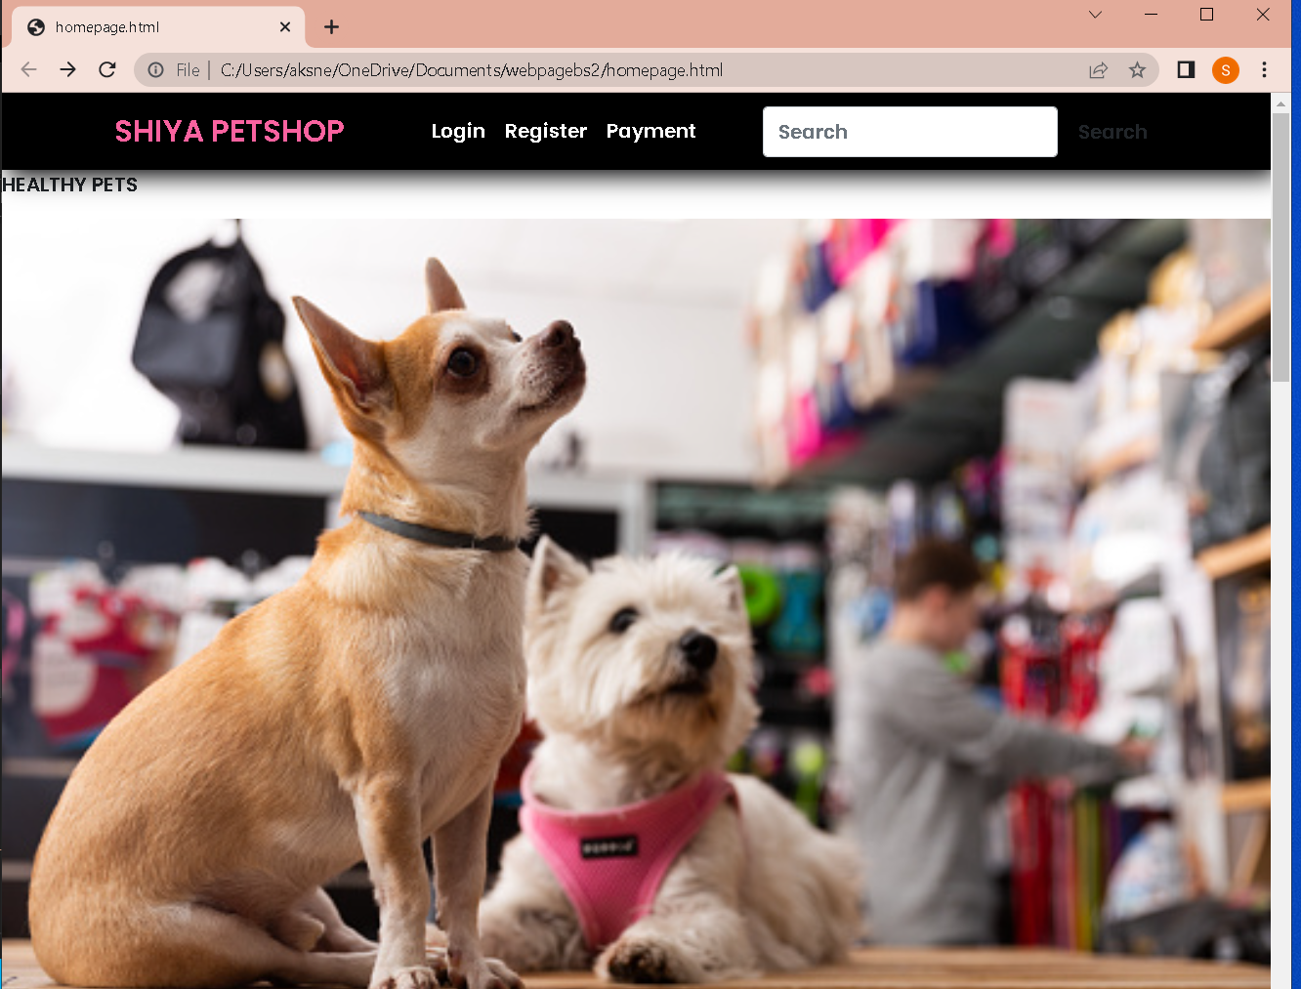

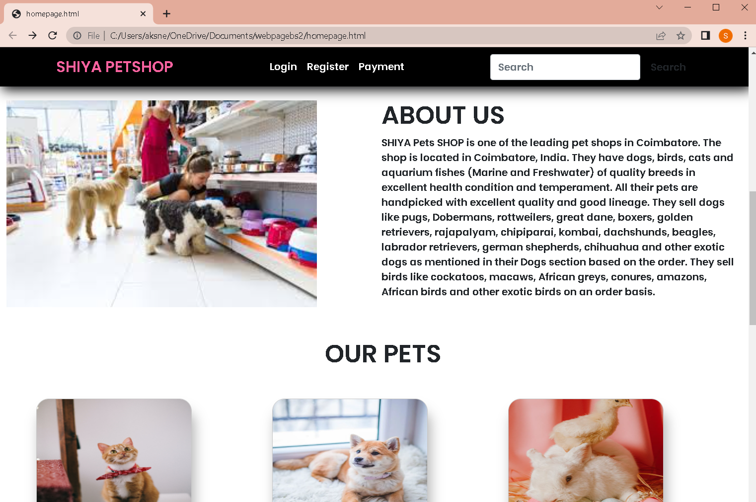

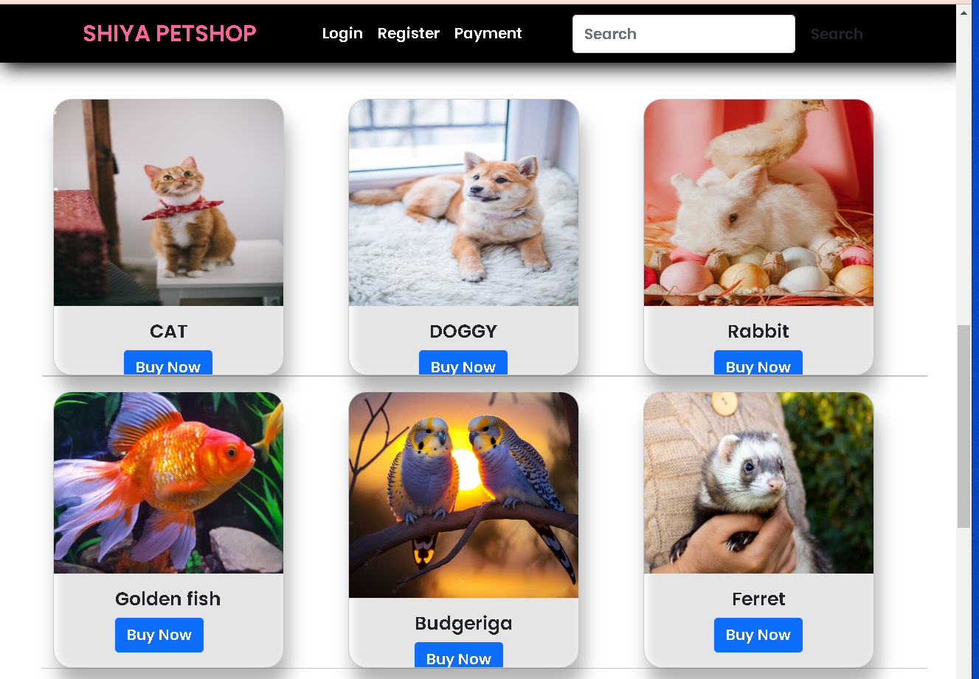

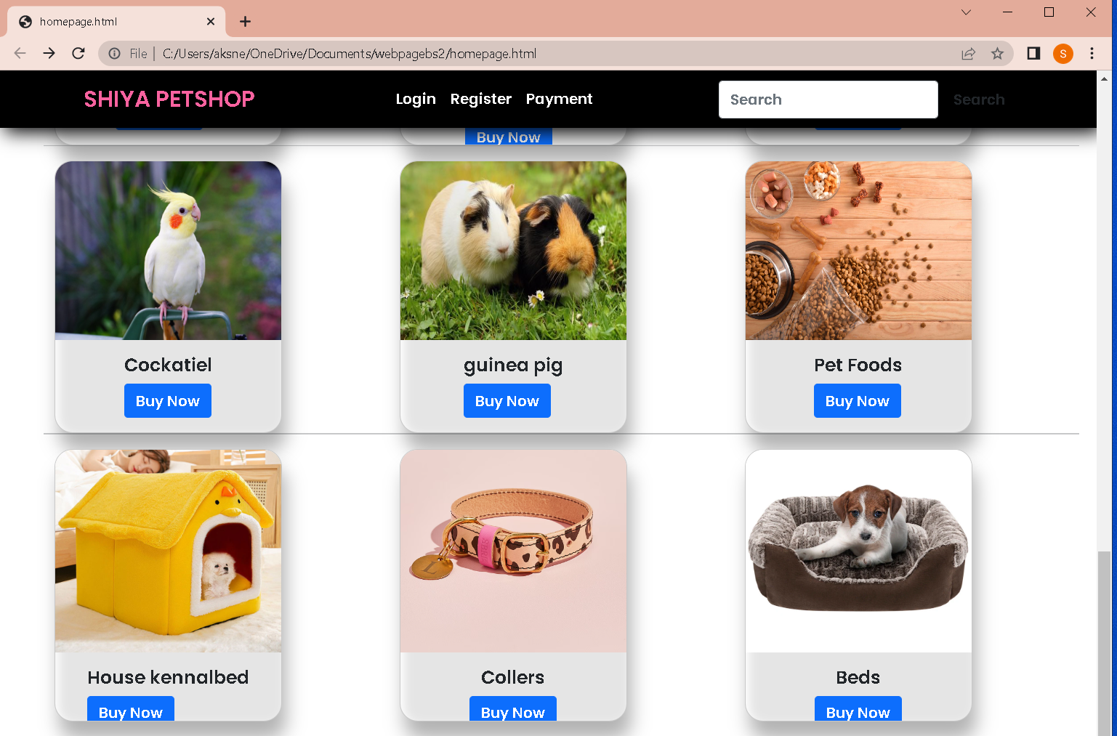

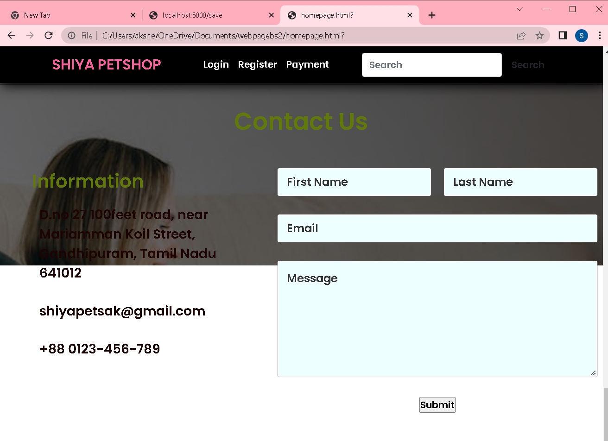

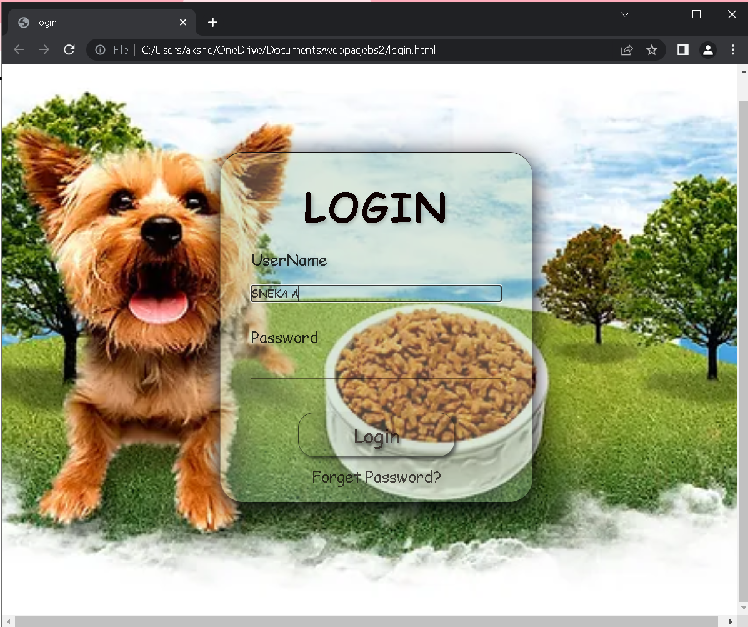

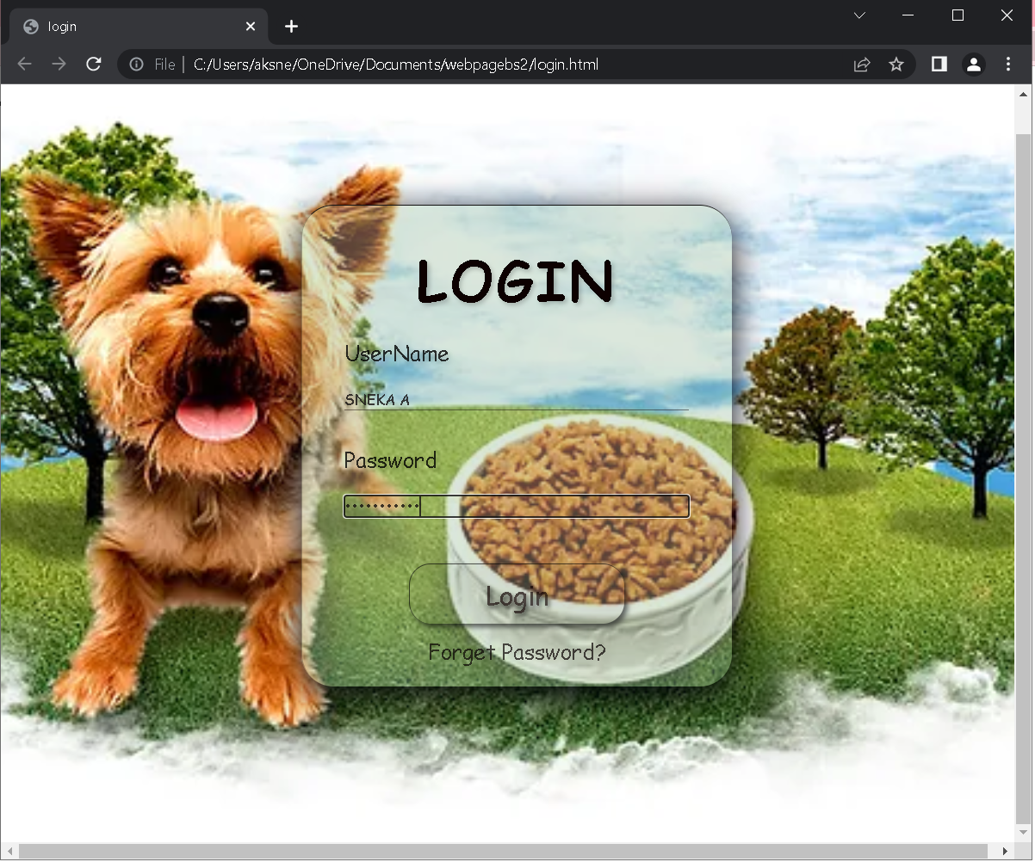

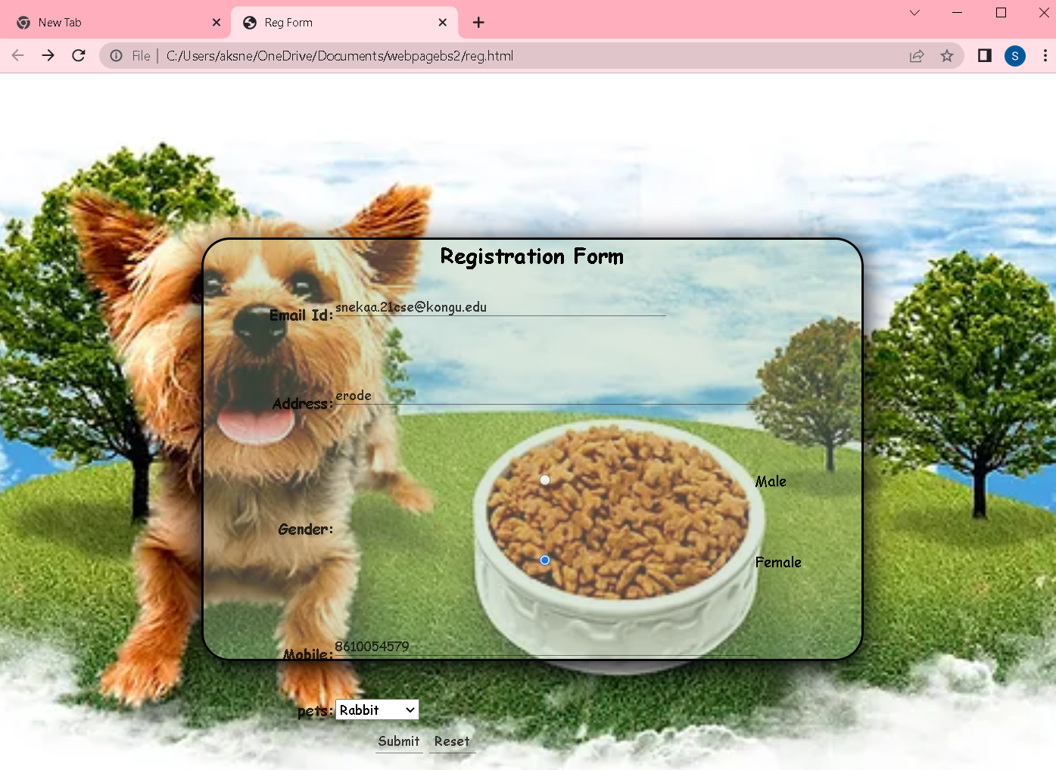

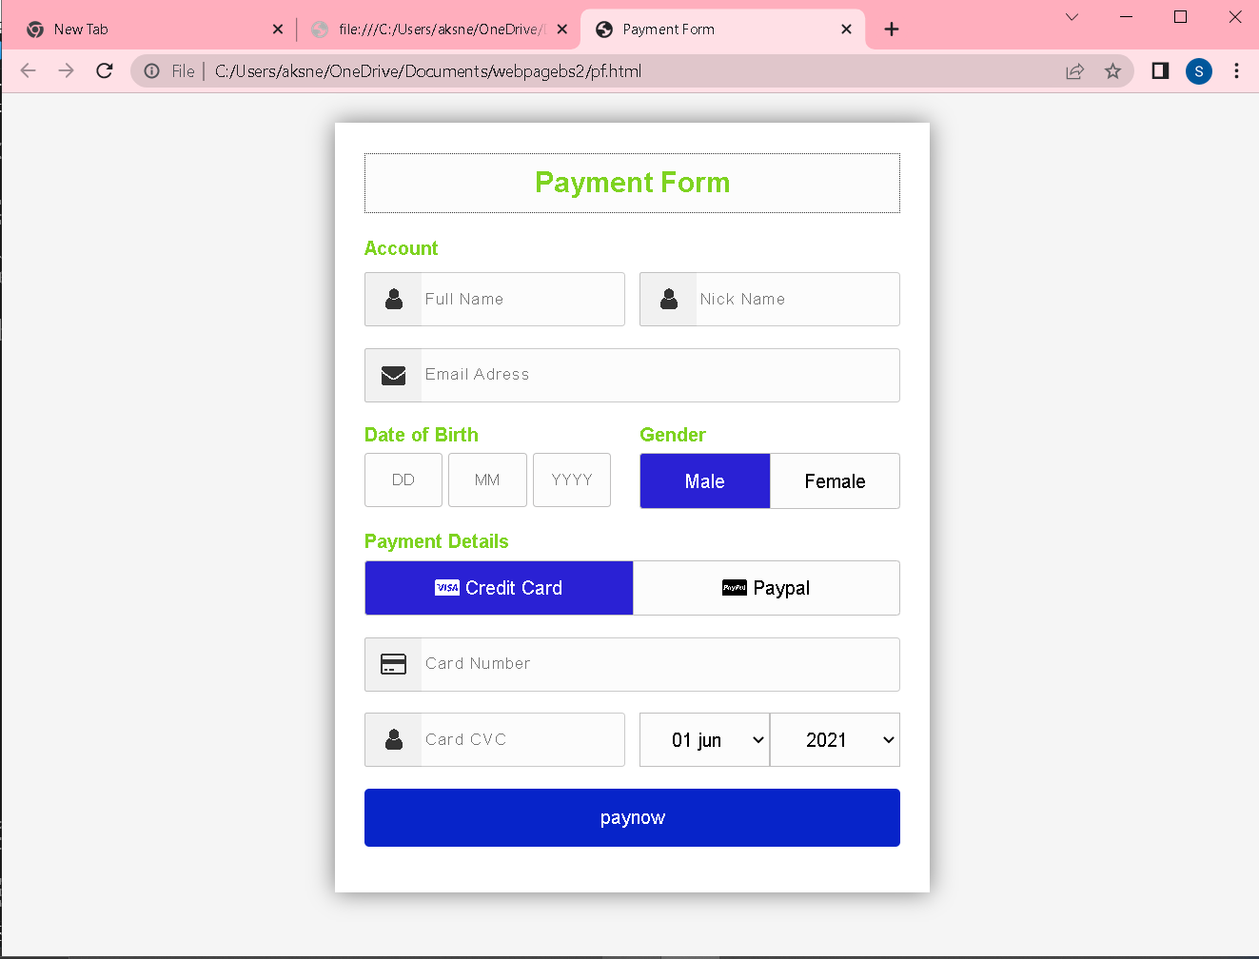

**RESULT:**

Thus, the online petshop application using HTML and CSS has been developed.